Project Design Phase-II
Data Flow Diagram & User Stories

Date | May 2023
Team ID | NM2023TMID06580
Project Name | Accessing the Safety of Municipal Drinking Water

Data Flow Diagrams:
A Data Flow Diagram (DFD) is a traditional visual representation of the information flows within a system. A neat and clear DFD can depict the right amount of the system requirement graphically. It shows how data enters and leaves the system, what changes the information, and where data is stored.
Example: Accessing the Safety of Municipal Drinking Water
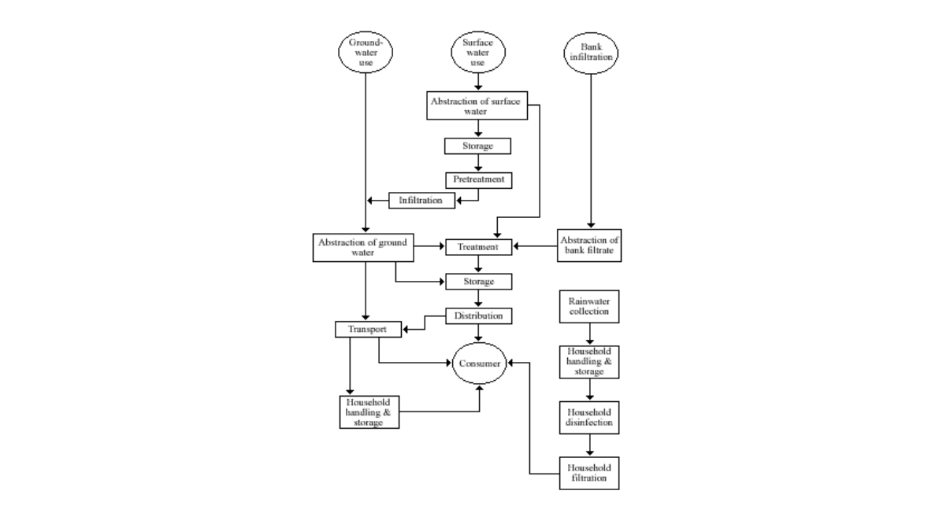

User Stories
Use the below template to list all the user stories for the product.
User Type | Functional Requirement (Epic) | User Story Number | User Story / Task | Acceptance criteria | Priority | Team Member
Customer (Mobile user) | Registration | USN-1 | As a user, I can register for the application by entering my email, password, and confirming my password. | I can access my account / dashboard | High | Sashank
 |  | USN-2 | As a user, I will receive confirmation email once I have registered for the application | I can receive confirmation email & click confirm | High | Santhosh
 |  | USN-3 | As a user, I can register for the application through Facebook | I can register & access the dashboard with Facebook Login | Low | Mohan
 |  | USN-4 | As a user, I can register for the application through Gmail |  | Medium | Jagadeesh
 | Login | USN-5 | As a user, I can log into the application by entering email & password | I can access my account after login by entering email and password | High | Sashank
 | Dashboard | UNS-6 | As a user I can get my account details in my dashboard | I can access my personal information in my dashboard | High | Mohan
Customer (Web user) | Registration | USN-1 | As a user, I can register for the application by entering my email, password, and confirming my password | I can access my account details | High | Jagadeesh
 | Login | USN-2 | As a user, I can log into the application by entering email & password | I can access my account after login | Low | Mohan
 | Dashboard | USN-3 | As a user I can get my account details in my dashboard | I can access my personal information in my dashboard | High | Santhosh
Customer Care Executive | Customer Management service system | USN-1 | As a user I will get my required service from the customer care system | I can get my service from my customer management system | High | Sashank
Administrator | User Management System | USN-1 | As an administrator, I want to be able to create and manage user accounts for the safety management system | The system should provide a secure and user-friendly interface for creating and managing user accounts. | High | Jagadeesh

